**KING ABDUL AZIZ UNIVERSITY**

**College of Computing and Information Technology**

**Department Of Information System**

**Assignment 1 Social Network Analysis**

|  |  |
| --- | --- |
| Student Name | ID |
| Shahad Al-sahafi | 1420182 |
| Shroog Al-attas | 1507701 |
| Shatha Al-aslani | 1507856 |

Team Members:

**Introduction**

We use Gephi social network analysis tool to display the data about Books for US politics. The data contains 105 Nodes that represent books about US politics sold by the online bookseller Amazon.com and 441 Edges that represent many co-purchasing of books by the same buyers, as indicated by the customers who bought this book also bought these other books feature on Amazon.

* **We imported "Books about US politics" dataset:**

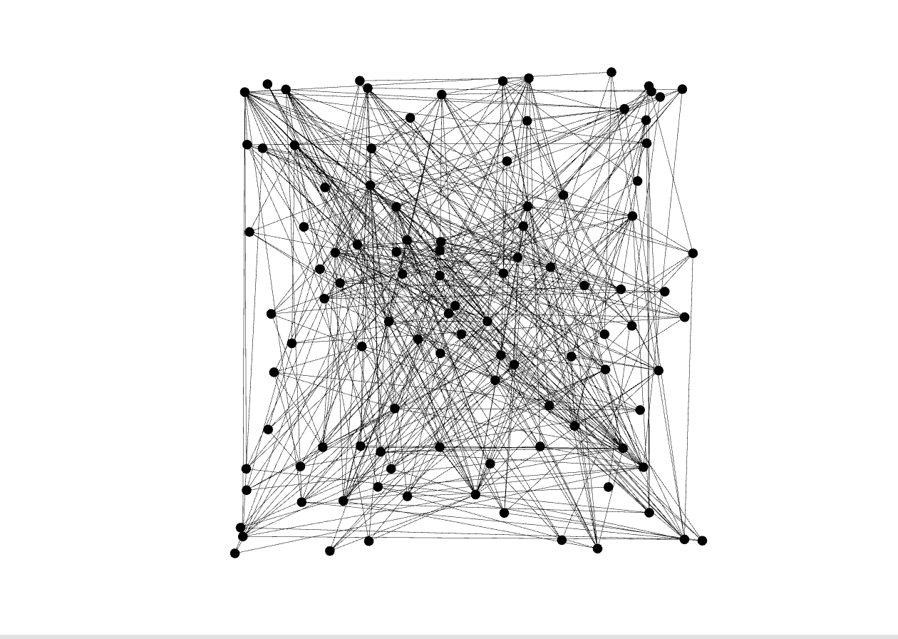

* **Layout The graph using "Force Atlas" module with 10000 Repulsion strength**

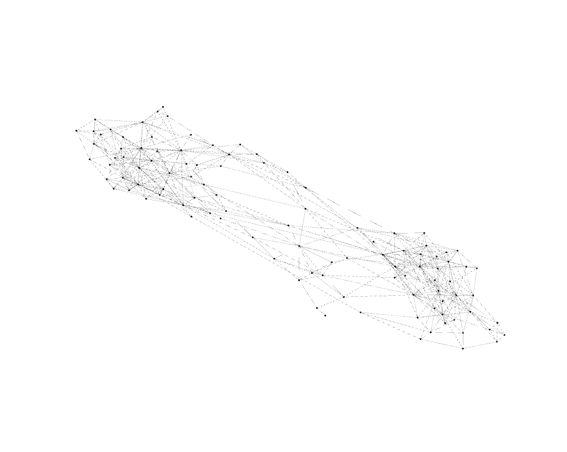

* 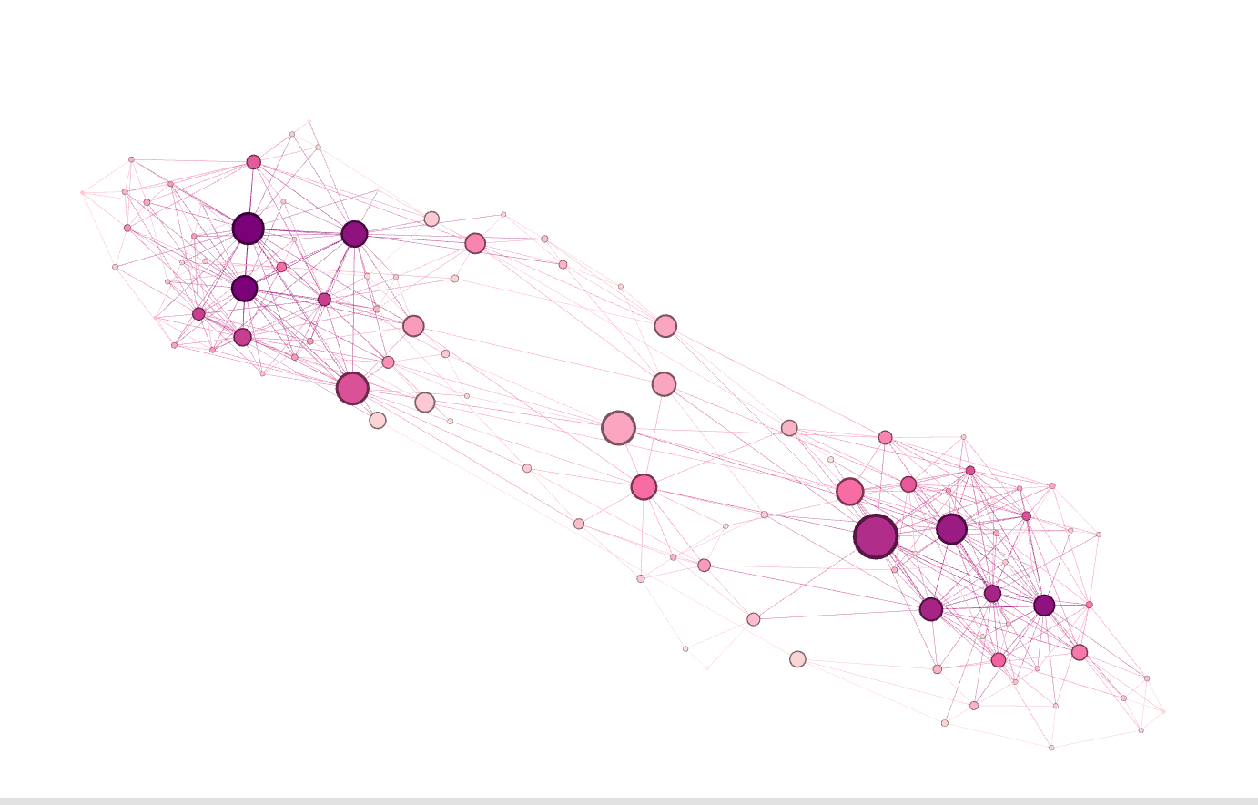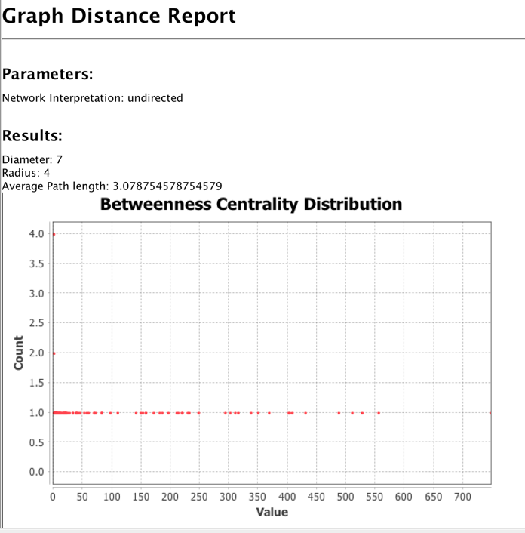**Betweenness** **centrality:**

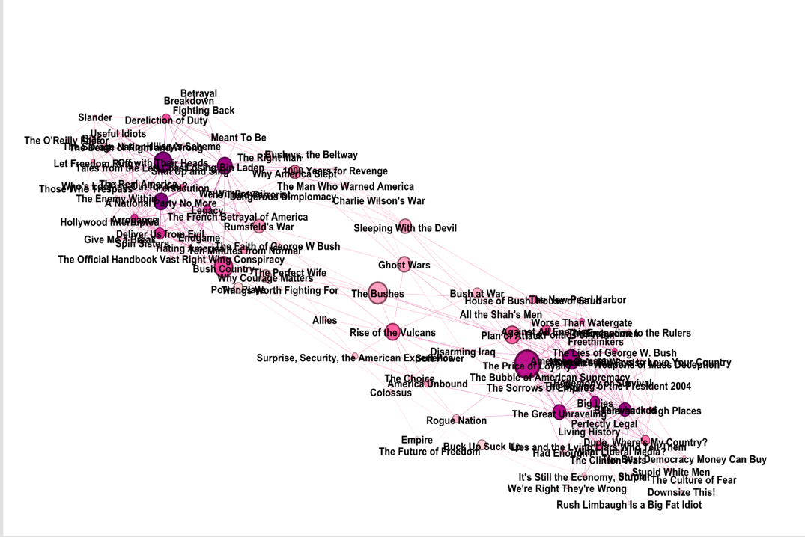

The figure displays "The price of Loyalty" book what is the most centralize node related to many books that customers bought together.

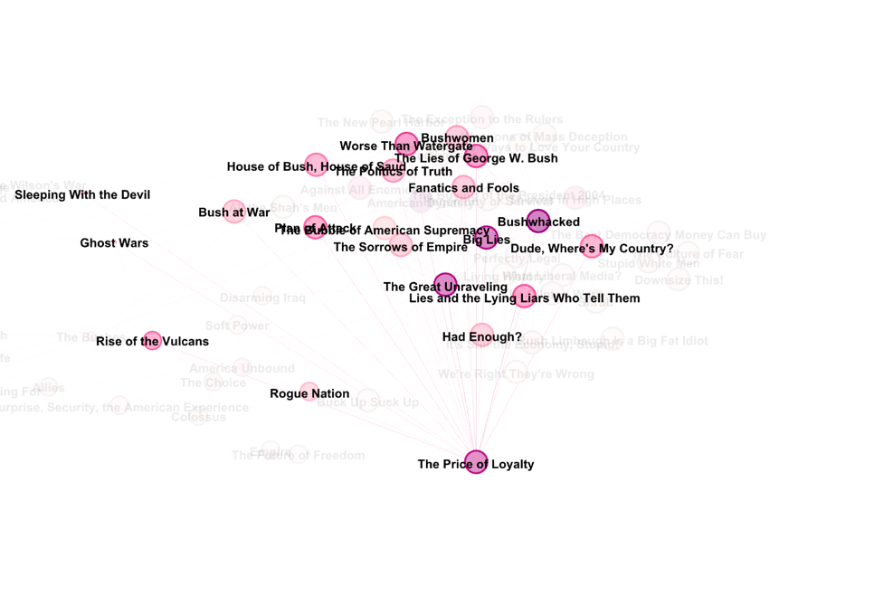

* **Degree centrality:**

The figure is shown below the Degree Distribution of dataset the value represents degrees and the count represent books, for example, how many books take 4 degrees? It was 14 books.

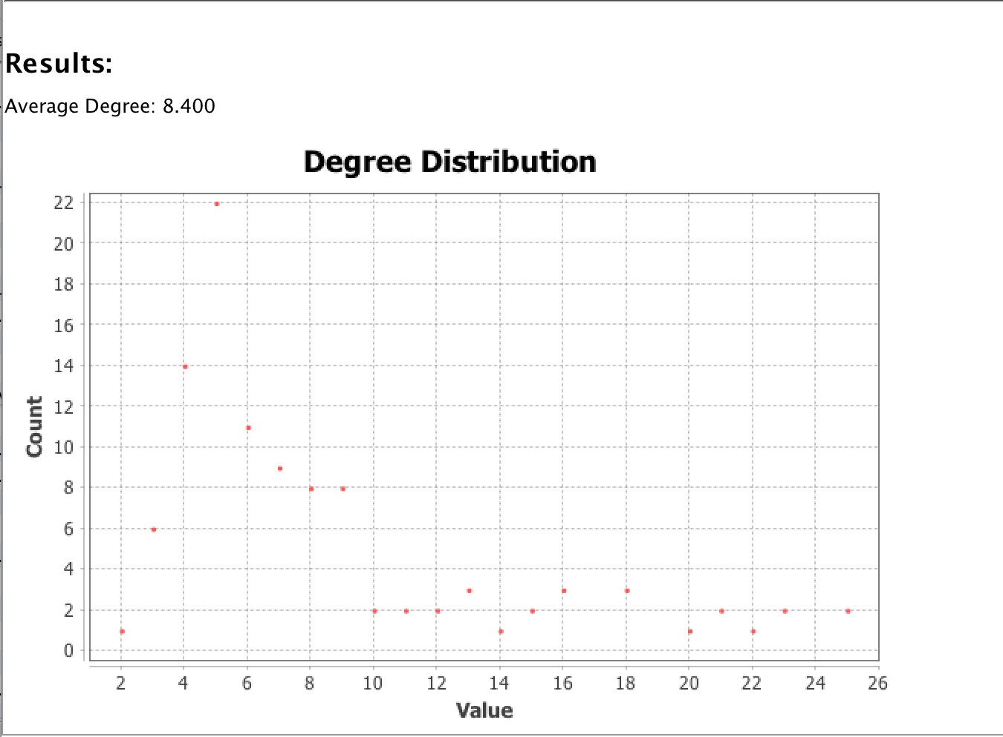

* **Closeness** **centrality**:

The Closeness centrality was weak in Books about US politics dataset because the customer does not need to buy more than book together. The figure is shown below the Closeness centrality in Data Table.

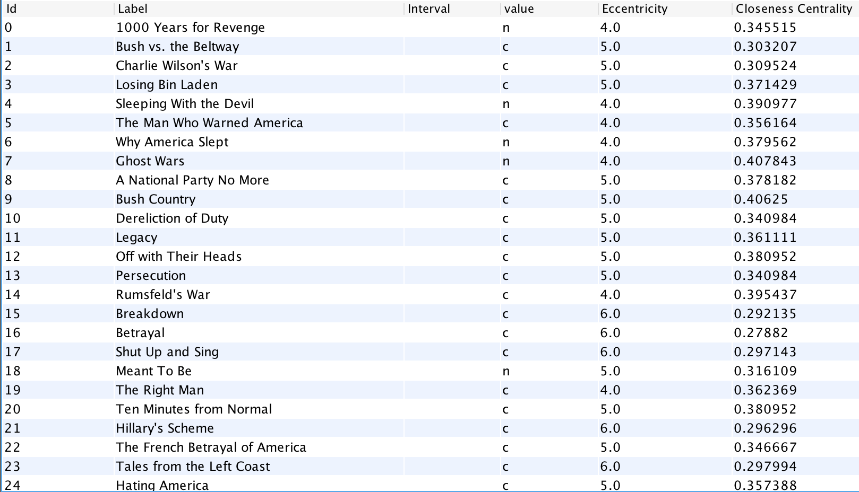

**Conclusion**

Finally, it was a great experience, and we learned how to use a kind of social network analysis tools what is Gephi, which is essential for companies to extract values and exploit the available possibilities. It is an essential tool and can use in more than a field.